**Task 1**: Create a dashboard in Power BI for Claire that reflects all relevant Key Performance Indicators (KPIs) and metrics in the dataset. Get creative!

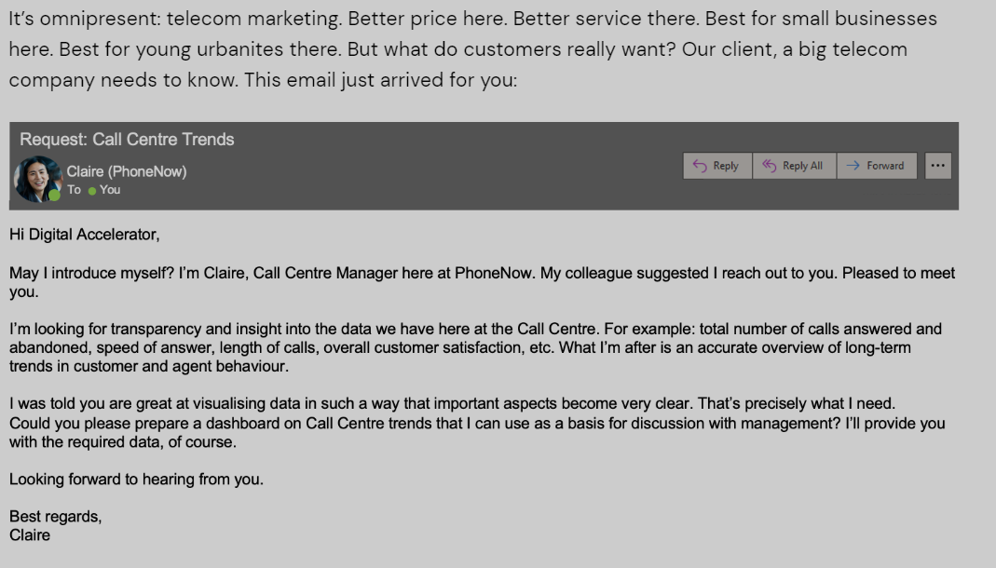

**Task2** :

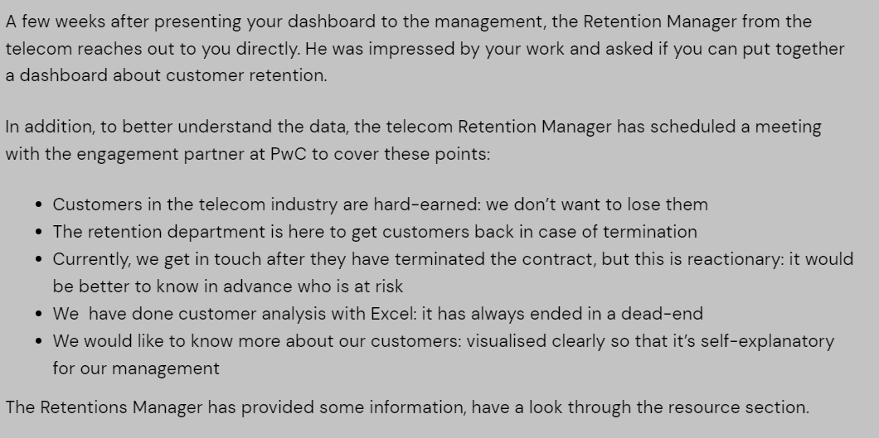

Your colleague, the engagement partner, asks you to do the following tasks:

1. Define proper KPIs
2. Create a dashboard for the retention manager reflecting the KPIs
3. Write a short email to him (the engagement partner) explaining your findings, and include suggestions as to what needs to be changed

**Task 3:**

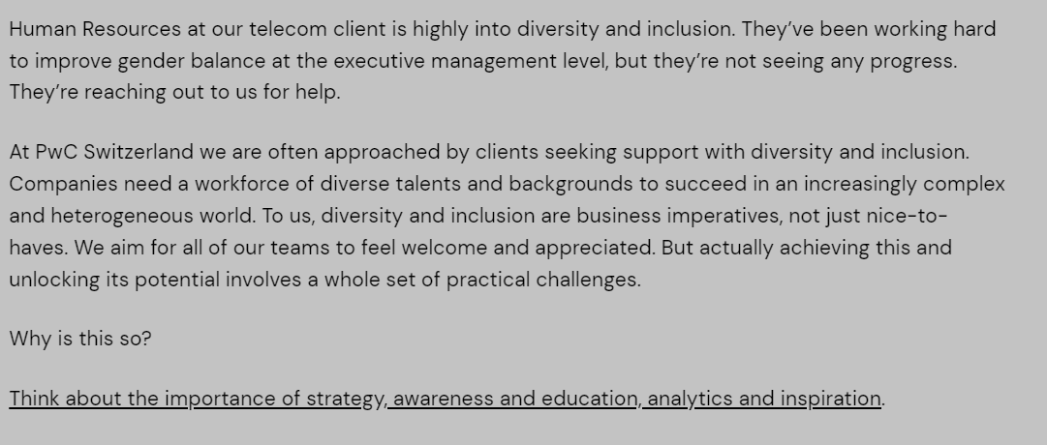

**Your task** is to do the following:

1. Define relevant KPIs in hiring, promotion, performance and turnover, and create a visualisation
2. Write what you think some root causes of their slow progress might be